**Cloud Managed Support**

**Version# 0.1**

**14 November 2016**

**Change History**

|  |  |  |  |  |  |  |
| --- | --- | --- | --- | --- | --- | --- |
| Version No | Date | Reasons & Triggers | Change Summary | Owned by | Reviewed by | Approved by |
| 0.1 | 14-11-2014 | Create a new doc |  | Vijay Thurimella | Vijay Thurimella |  |
| update | 10-07-2015 | Updated with client info | Added client contact and made it more product specific | GSO | Vijay Thurimella |  |
| 0.3 | 01-10-2015 | Update with NHS | Updated with NHS product info | GSO | Vijay Thurimella |  |

1 Overview 4

1.1 Goals and Objectives 4

1.2 Deployment Models 5

1.3 Critical Success Factors 5

1.4 Support framework 6

1.5 Measurement and Reporting 6

1.6 Support Offerings 7

2 Support Services 8

2.1 Support organization 8

2.2 Roles and Responsibilities 9

2.3 Support Coverage 9

2.4 Support Communication Channels 10

2.5 Service Scope 10

2.5.1 In Scope 10

2.5.2 Out of Scope 10

3 Software Agreement 11

3.1 Termination of Software Support & Maintenance Service 11

3.2 Reinstatement Policy 11

4 Problem Management 11

4.1 Enhancement Request Processing 12

4.2 Product Bugs 12

4.3 Release Types 13

4.4 Move to Production 13

5 Master Data Update 14

6 Incident Management 15

6.1 Incident Lifecycle & Workflow 15

6.2 Requesting access to support portal 17

6.3 Working with Support 17

6.4 Incident Severity 18

6.5 Service Level targets 18

6.6 One Ticket - One Issue Policy 19

6.7 Incident Closure policy 19

6.8 Incident Re-assignment process 19

6.9 Incident re-open process 19

6.10 Incident Escalation 19

6.11 Service Maintenance & Downtime 20

# Overview

## Goals and Objectives

The purpose of the Cloud Support Plan is to provide a description of the overall strategy for management of the Cloud applications post implementation. This recommendation includes a staffing model to support the end users and a list of tools and technology needed by the support staff. This document is focused on the long term Post Implementation Support goals.

* Establish a methodology and structure to manage and support the production environments with the appropriately skilled people, tools and procedures
* Establish a strong governance program to manage the applications
* Balance the business requirements between all groups and ensure the systems are operating effectively and efficiently
* Ensure a periodic comparison of business needs with new functionality available
* Establish a comprehensive, scalable support team to support the day to day support needs of diverse products
* Establish a work environment that fosters the sharing of knowledge and resources across all applications and leverages understanding of technical, functional and integration knowledge
* Establish and maintain end user system knowledge by providing ongoing training and Help Desk support.

Cloud Computing ArchitectureCloud Computing Architecture
 

## Deployment Models

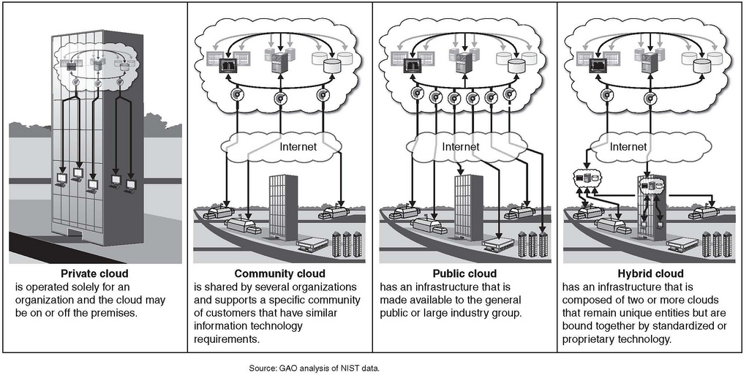

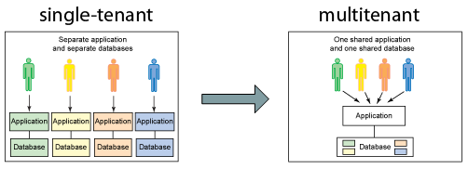

## Critical Success Factors

To ensure the success of the long term Support environment the following critical success factors must be achieved:

* An efficient support model developed and established prior to turnover to operational status
* Comprehensive documentation – technical, functional and user
* Shared understanding of roles and responsibilities of all support staff members with cross functional teams and users
* Knowledge transfer from product management and engineering to Support Staff
* Training of all users and Support Staff to an appropriate competency level
* Acceptance of the processes and processing environments by end users
* Adequate support resources and ongoing funding to support the long term application support needs of the organization.

## Support framework

* Strategy: A service that supports the business and improves value over time
* Governance: Structures and procedures that measure performance and achieve compliance.
* Organization: The right resources available at the right time to support & enhance the system.
* Process: Processes resulting in efficient and effective application management.
* Technology: Tools that enable the support processes, governance and organization.

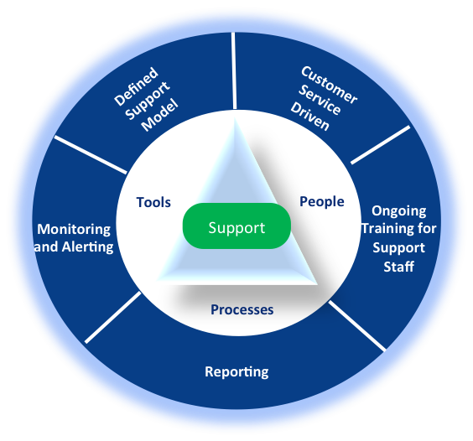

## Measurement and Reporting

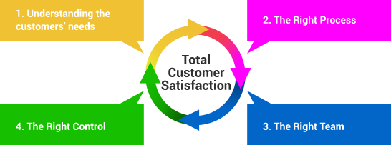

Application is governed via specific service agreements that comprise of a number of SLAs. Metrics are a critical ingredient of an SLA. There are dozens of metrics that could be measured for application support and maintenance services. These metrics are related to

**Operational Support Services –User Support**

**User Support Work Backlog** - This is the total volume of user support requests submitted in a time period that remain open and unassigned. Increased backlog, indicates that the application may not be designed or documented well, or may have significant gaps between actual and desired functionality. It may also be an indicator of inadequate support staffing, or a growing user community.

**Performance Metrics** - These are output metrics that indicate how much work is done. A high volume of requests closed in a time period may not be a reason to rejoice; it may point to other problems that are leading to a high demand for this service.

**User Support Work Volume** - This is the total volume of support requests closed in a time period. This metric is an indicator of how much work the production support team is completing in a time period.

**Customer Satisfaction Metrics** - These are output metrics that help you determine what the perception of the recipients of the service is.

**Application Maintenance Services – Enhancements and Maintenance**

**Customer Demand Metrics** - These are input metrics that indicate how much work is requested.

**Enhancements & Maintenance Work Backlog** - This is the total volume of enhancement requests submitted in a time period that remain open and unassigned. If the enhancement work backlog increases between multiple time-periods, it is an indicator that the application may have significant gaps between actual and desired functionality. It may also be an indicator of inadequate staffing, or poor productivity.

**Priority Request Aging** - This is the total volume of priority maintenance work requests submitted in a time period that remain open and unassigned grouped by number of days since open. Business users become dissatisfied when the high priority requests in the backlog increase. It may also signal inadequate or incorrect prioritization processes.

**Re-Work Requests** - This is the total volume of maintenance requests that are re-opened in a time period. The request tracking system may not allow requests to be re-opened; see if you can link new requests to existing requests that have been re-opened.

## Support Offerings

|  |  |  |
| --- | --- | --- |
| Maintenance Features | Standard $ | Premium $$ |
| 9 X 5 support (9:00 a.m.–6:00 p.m., Mon–Fri, local time) | X | X |
| 24/7 support availability |  | X |
| Support Knowledge Base access |  | X |
| Napier Support Portal access | X | X |
| Response to Site Down calls within 1 hour | X | X |
| Weekends, Off Business, Holiday Support – Critical & non critical |  | X |
| Product Bug fixes | X | X |
| Local language Support |  | X |
| Product enhancements, upgrades, version updates |  | X |
| Customer Relationship Manager |  | X |

# Support Services

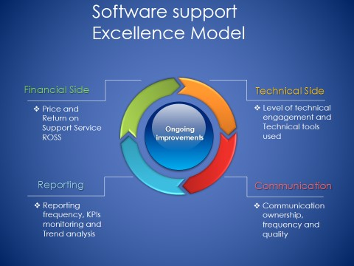

## Support organization

**Napier Support** - responsible for installing, configuration the application and ensuring its operational 24/7 and performing necessary housekeeping and maintenance activities as required. This team would also assist the customer in all functional issues and escalate any issues requiring assistance from engineering or product management for bugs or enhancements to the product.

**Product management** – are the product owners and responsible for determining if a customization request is legitimate and is really required for the functioning of the product. The team would determine if a request is an enhancement and is necessary and needs immediate attention and is a product feature enhancement and is part of a product upgrade.

**Engineering** – the developers of the product and owner of the product source code. Any changes to the code would be performed by this team, such as bug fixes, enhancements, version upgrades.

**Infrastructure Support (ISS)** - The IT support team responsible for deploying, maintaining the hardware, software, infrastructure including the networking required and also coordinating with the cloud vendor for hosted hardware’s.

**Cloud Vendor** - The service provider is responsible for providing the hardware, OS required and subscribed to as part of the application hosting requirement.

## Roles and Responsibilities

**Support Manager**

* Manages all aspects of management of the application software including maintenance and development and functional and technical team user support
* Manages the application change request and problem resolution process
* Works with team to develop application development plans including minor upgrades, patches and fixes, problem resolution, change requests and enhancements
* Develops training plans to ensure ongoing development of application team
* Works collaboratively with Org Change/Training Team to develop communication and training to support end user readiness

**Application Support Engineer**

* Acknowledge issues from customer through support portal, telephone and triage with internal teams for resolution
* Talks to user to learn procedures followed and source of error
* Provides options for issue resolution and identifies business process improvement opportunities
* Provides functional application and business expertise to support end users
* Delivers training to end users in support of upgrades, enhancements
* Documents functional requirements to support application service requests

## Support Coverage

|  |  |  |  |
| --- | --- | --- | --- |
| Shift | Time | Coverage | Location |
| Morning | 06.30am to 3.30pm IST | APAC | India |
| Afternoon | 1.30pm to 10.30pm IST | EMEA | India |
| Night/US Day | 09.00am to 6.00pm EST | Americas | USA |

***Full Support*** - Monday – Friday business hours (8am to 5pm local time) by phone and web portal except for holidays as defined below as *Limited Support*.

***Evening and Weekend Support*** - Limited **support** for production related critical issues only, by phone and or web portal

* ***Limited Support - Monitoring*** *and responding to critical items only.  Limited Support applies to the Napier specified India holidays*
  + Non critical issues would be addressed based on discussion with customer

## Support Communication Channels

|  |  |  |
| --- | --- | --- |
| **Channel** | **Service** | **Description** |
| Support Portal | http://support.napierhealthcare.com:8082/osticket/ | The most efficient method for creating incidents and finding updates. |
| Telephone | United States : **1-844-781-6069**  Singapore : **8001891051**  Australia : 1800870860 | The recommended communication method for critical/high severity issues that require rapid response and action. |

## Service Scope

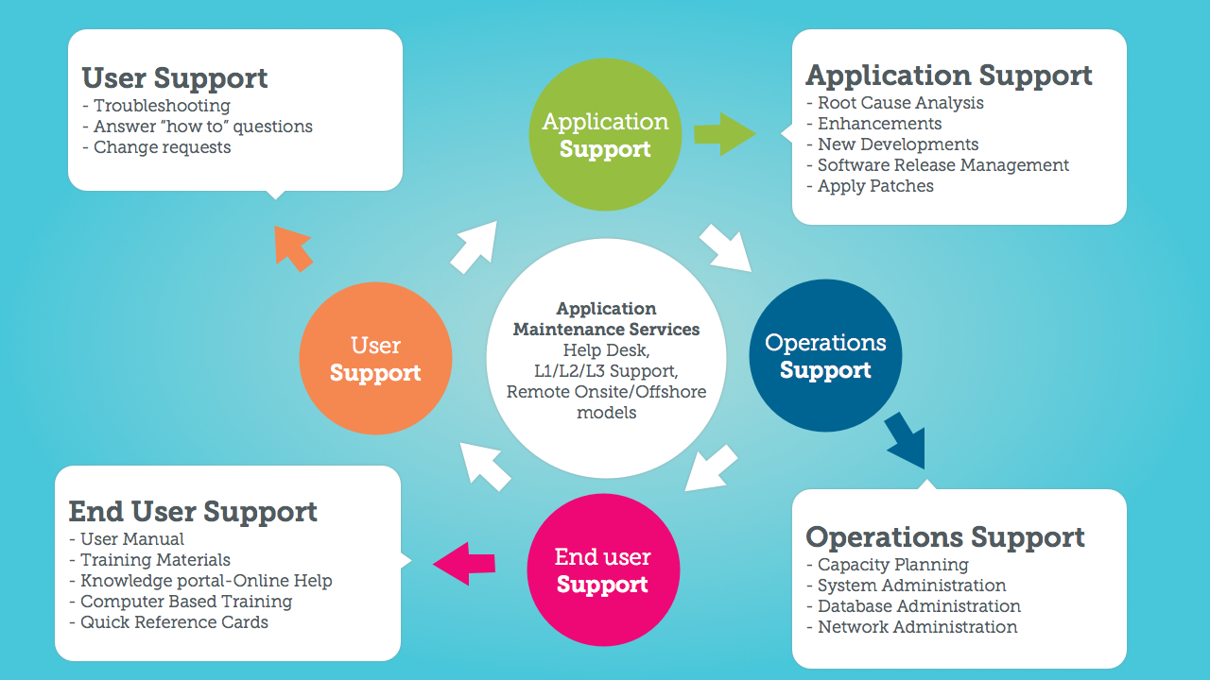

The primary responsibilities and the actions to be performed for any out of scope activities. The support would escalate any out of scope requests to the appropriate internal team or with discussion with their senior managers based on the availability of skill, expertise would assist in solving the query of the customer.

### In Scope

* Incident Support - Identifying and troubleshooting problems in the application & Root cause analysis
* Deploy, manage, maintain cloud hosted applications on production
* Triage with cross functional teams for bugs and enhancements, Infrastructure issues
* Respond to how to queries, feedbacks, concerns related to product, support, documentations etc.

### Out of Scope

* System related activities, including system performance, DB performance, updates
* On-site support, unless agreed with the Napier Support Manager, as part of an active
* plan of action to resolve an escalation scenario Professional services, unless specified in the service offering purchased, such as, but not limited to, system audits, system benchmarking or custom report generation. These services would need to be defined and priced separately under the terms of Professional Services
* Support for interfaces to data sources not expressly included in the License Agreement
* Data management, data retrieval, data file copying or distribution, administration and other routine
* operational responsibilities

# Software Agreement

## Termination of Software Support & Maintenance Service

Napier Software Support and Maintenance agreement may be cancelled prior to the end of a term by providing notice to NAPIER. We may terminate any NAPIER Software Support and Maintenance agreement by providing written notice at least 60 days prior to the Maintenance Expiration

Following would be the reasons for terminating a contract

* User decides to move to a different service provider
* User has not paid the maintenance renewal fees
* The current product has reached end of life and replaced by a new product
* License and maintenance conditions were breached by User
  + Code modified by a third party
  + Reused the license without informing Napier

## Reinstatement Policy

If Napier Software Support and Maintenance policy was not renewed by the Maintenance Expiration Date, support will be systematically terminated. If you wish to obtain coverage for any licenses at a later date, you may reinstate a Software Support and Maintenance plan by

* Working with the support manager
* A reinstatement fee, calculated as a multiple of the fee (typically three times), will be assessed to continue service.
* The new fees would be based on the current valuation and not based on the original terms and conditions in the previous contract if any

# Problem Management

Any problem reproduced as a generic product issue (Defect) or change request to overcome an identified functional limitation (Enhancement Request) will be reported to Napier Product Management via a Problem Report, documented in a knowledge base article and made visible to Napier customers via the Support Portal. The analysis of a Problem Report will result in the identification of a Software Change Request (SCR) required to deliver a resolution to a Defect or Enhancement Request.

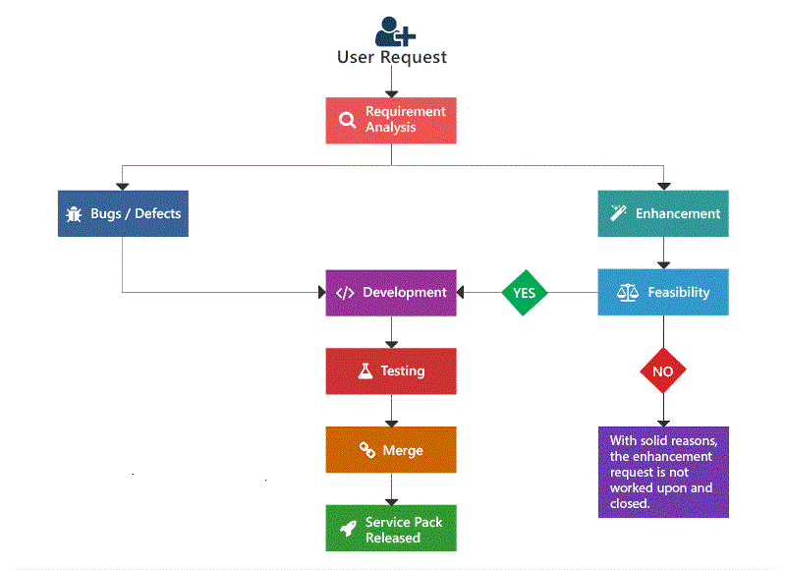

## Enhancement Request Processing

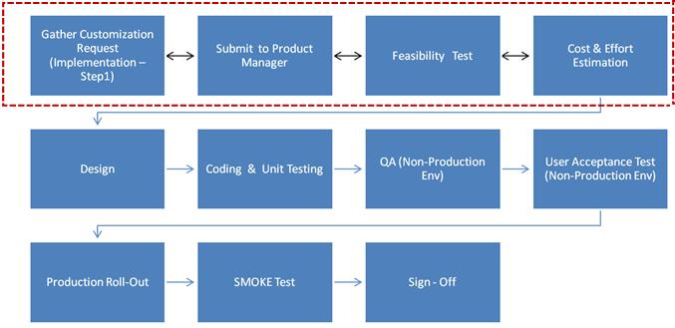

Enhancements are any modification, update, upgrade or addition to the Solution that, when made or added to the Solution or its modules currently being used provides minor functionality enhancements but does not change overall utility, functional capability, or application.

All enhancements will be handled by product management

* Custom or generic requirement
* If custom, costing and estimation
* If generic, the release timeline or if the same can be delivered or not

## Product Bugs

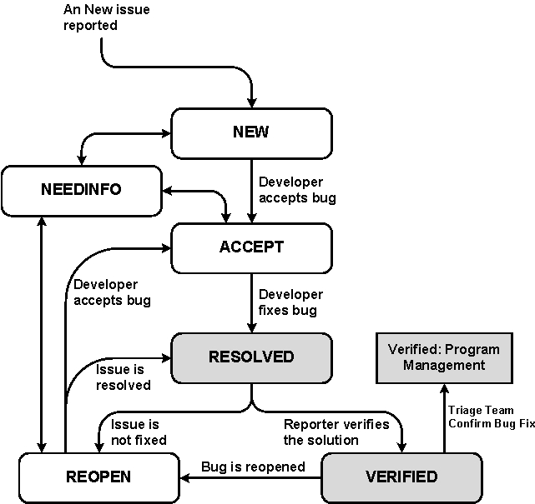

Bugs are any modification or addition to the Solution that, when made or added to the Solution or its modules currently being used corrects Errors but does not change overall utility, functional capability, or application,

* Maintenance (bug fix) releases come out more frequently than major releases, and attempt to target the most critical bugs affecting our customers.

Critical Bugs - (production application down or major malfunction causing business revenue loss or high numbers of staff unable to perform their normal functions) we'll fix it in the next maintenance release, provided that:

* The fix is technically feasible (it doesn't require a major architectural change)
* It doesn't impact the quality or integrity of a product

For non-critical bugs, the developer assigned to fixing bugs priorities the bug according to these factors:

* How many of our supported configurations are affected by the problem
* Whether there is an effective workaround or patch
* How difficult the issue is to fix?
* Whether many bugs in one area can be fixed at one time
* The impact on the normal performance of the system
* Business hours or after office hours and holidays

## Release Types

|  |  |
| --- | --- |
| **Major Release** | * Major new features, architecture changes, product components * Full, standalone product build |
| **Minor Release** | * May include significant new features beyond previous minor/major version * Full, standalone product build * Will normally be localized |
| **Maintenance Release** | * May include previously released Service Packs and other fixes * Full, standalone product build |
| **Service Pack** | * Periodic rollup of Hot fixes and Patches * May only be a set of files, not a full, standalone product build * Released on a planned availability date * Recommended to all customers as part of a proactive maintenance plan * Will not normally be localized |
| **Patch** | * In response to a specific Software Failure * May only be a set of files, not a full, standalone product build * Released ad-hoc, as soon as available * Recommended to all customers to prevent a critical failure * Will not normally be localized |
| **Hotfix** | * In response to a specific customer-reported Software Failure * May only be a set of files, not a full, standalone product build * Released ad-hoc, as soon as available, via Tech Support only * Typically created in response to Severity-1 issues * Will not normally be localized |

## Move to Production

Deployment Plan – would outline the steps to be performed as part of deployment for major releases including the planned dates, timeline etc. This document would be shared with the stakeholders as part of the downtime communication notification

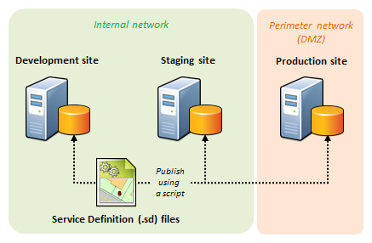

Development – provides the build, release notes and installation guide in a shared location

Support – follows the installation guide and deploy the code from the UAT in production

Product management – performs the test to certify and verify if the issue logged or the feature as part of the release has been solved or released

User/Customer – performs the verification test on UAT to certify if the issue faced has been resolved or the feature request has been provided in the build deployed.

* Would provide a sign off for the same to be move to production
* No code will be deployed to production late evenings, Sundays and India public holidays
  + Unless Engineering is available to solve any issues

**MTP Checklist**

* Release Notes
* Installation Guide
* Sign off email from customer from UAT
* Sign off email from Product Management
* Communication plan – stakeholders and project teams
* Documentations – technical, functional, User

# Master Data Update

Master data. Master data is critical business data shared among multiple systems. In healthcare, we divide master data into two types:

* Identity data—such as patient, provider, and location identifiers
* Reference data—which includes common linkable vocabulary like ICD, DRG, SNOMED, LOINC, RxNorm, and order sets

Master data management is, at its most basic, the process of linking identity data and reference data across multiple IT systems into a single, consistent point of reference. That single point of reference could be a patient, or it could be a procedure code. A more formal, all-encompassing definition we give to MDM is the following:

# Incident Management

A support incident is a single, reproducible issue, problem, or symptom. An “incident” for purposes of Napier Support is a request for assistance, or a question fully and accurately logged within the Napier Portal, or information requests about our Napier Support plans. Other commonly used names for an incident are “**case”, “inquiry”, “call”, “log”, “issue”, and “ticket”.**

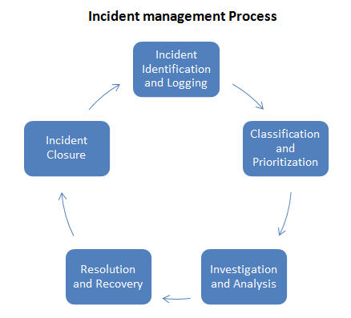

## Incident Lifecycle & Workflow

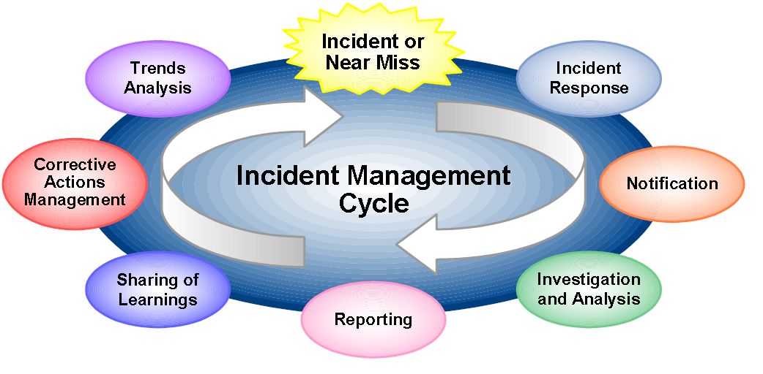

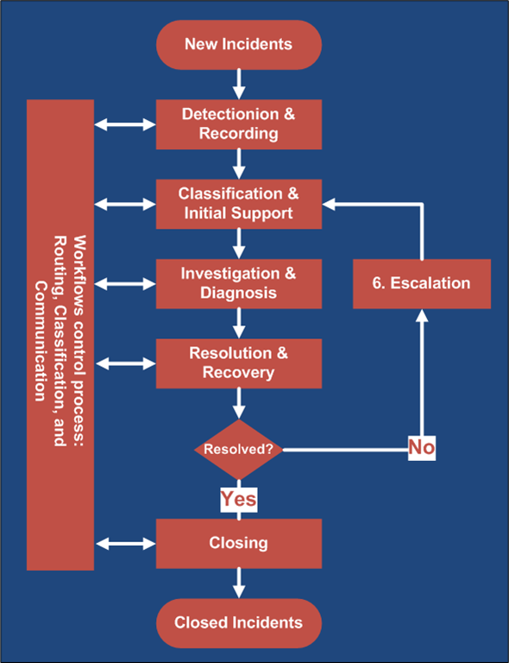

|  |  |
| --- | --- |
| Status | Description |
| New | A ticket was logged by the customer on the support portal with all the required details and contacted support for the first time |
| Work in progress | Request has been received by support and investigation and analysis has begun |
| On Hold | Support has put the investigation on hold, as it is waiting for information from L2/Customer or performing a testing scenario and awaiting result |
| Awaiting information | Support team needs some clarification from the customer or the L2 support and awaiting the same to further progress |
| Resolved | Solution has been provided to the customer after simulating the same in-house with the solution or a fix has been provided by engineering |
| Awaiting closure confirmation | Resolution has been provided to customer and awaiting confirmation that it has been resolved and the ticket can be closed |
| Closed | Customer has confirmed that the issue has been resolved and can be closed |
| Reopen | Customer has come back that the issue has not been resolved, support will re-open the ticket |

**Napier Application Support (Level 1)**

Napier provides first line (L1) support for issues that can’t be handled by the customer or for which

customers require additional information/clarification to ensure continued system availability.

* Knowledge base searching to verify if reported problems are already known issues with a defined resolution plan
* Impact analysis with accurate classification of reported issues to ensure appropriate prioritisation
* Qualification/replication of the reported issue in an appropriate customer environment
* Initial triage to isolate unsupported 3rd party issues from potential root cause
* Information gathering to ensure complete availability of details required for root cause analysis
* Provision of technical resolution or problem workaround
* Problem routing/escalation to second/third level support or third parties where required
* Integrated 3rd party product support
* Defect verification with full documentation of replication environment and workflow
* Defect Software Change Request (SCR) escalation

**Napier Engineering Response Team (Level 2)**

The Napier Engineering Team provides second level support services for back-to-back consultation with Napier Technical Support, including the delivery of maintenance releases satisfying SCRs.

* Escalation support for unresolved second line technical support issues
* Workaround analysis for escalated product defects
* Defect resolution through the deployment of hot fixes and maintenance releases
* Defect roll-up/back-port between code branches
* Product Quality Assurance and acceptance testing
* Service availability and capacity management for hosted services
* Restoration of service outage for hosted services

## Requesting access to support portal

Support team would request the following information to provide access to the support portal

1. Customer name – organization
2. List of users requiring access
   1. First name, last name
   2. Work/mobile phone number
   3. Work email address
3. Primary contact – for escalation email notifications

## Working with Support

Before contacting Napier Support, please follow the process provided below:

* Ensure that you have been registered as a Napier customer support contact.
* Review the product documentation, including troubleshooting instructions.
* Ensure that you have a supported system configuration.
* Document all pertinent information regarding your deployment, such as: Product name and version, hardware, operating system, and database, and description of the problem.

Fill Mandatory Fields

* Help topic – Service Request
* Category
* Product Name
* Severity – Critical/medium/Low
* **Issue** - Complete description with as much detail as possible.
* **Steps to Reproduce** - Include all pertinent steps leading to issue and the details (Job Title and User Class) of the user experiencing the issue.
* **Environment Information** – List the environments that the issue is occurring in. Also provide ANY and ALL changes that have been made in the environment since the last time the scenario worked without an issue, and any other special notes about the environment in which the issue is occurring.
* **Impact to Business** – Provide a clear description of impact to the business including as applicable, # of users impacted, # of processes impacted, data impacted, financial impact etc.
* **Attachments** – if any, always helpful for remote troubleshooting

## Incident Severity

|  |  |  |
| --- | --- | --- |
| Level of Severity | Characteristics | Response |
| Critical Business Impact:   1. Critical issue occurring on production system preventing business operations. A large number of users are prevented from working with no procedural workaround. | 1. System hangs or crashes 2. Critical functionality not available 3. Data loss or data corruption 4. Large number of end users blocked from work & Impact is escalating quickly | 1 hr. |
| Medium Business Impact:  Major issue occurring on production system severely impacting business. A large number of users are impacted by issue but they are still able to work in a limited capacity. | 1. Significant performance degradation 2. Important functionality not available 3. Small number of users blocked from work & Impact is escalating | 4 hrs |
| Low Business Impact:  issue occurring on non-production system or question, comment, feature request, documentation issue or other non-impacting issue. | 1. Incorrect product behaviour without impact 2. Product question or enhancement | 8 hrs |

* **Initial Severity Level** - NAPIER will record an initial severity level of the service request based on the severity definitions defined above. Napier’s initial focus, upon acceptance of a service request, will be to resolve the issues underlying the service request. The severity level of a service request may be adjusted as described.
* **Downgrade of Severity Levels** - If, the issue no longer warrants the severity level currently assigned, based on its current impact on the production operation of the program, then the severity level will be downgraded to the severity level that most appropriately reflects its current impact.
* **Upgrade of Severity Levels** - If, the issue warrants the assignment of a higher severity level than that currently assigned, based on the current impact on the production operation of the SaaS program, then the severity level will be upgraded to the severity level that most appropriately reflects its current impact. In requesting any assignment of a higher severity level, you must provide NAPIER with sufficient information that demonstrates the increased impact of the issue on the production operation of the service.

## Service Level targets

|  |  |
| --- | --- |
| Milestone | Description |
| Response | Initialization of the support process, through engagement with the customer to progress information gathering, analysis or issue replication. |
| Resolution | Provision of a solution to an incident or problem, either by employing a temporary fix, an answer or a technique that provides a solution to the reported problem |
| Hot Fix | Return of the user experience to the normal or expected status through implementation of a code change that resolves the incident or problem. |

Napier Support attempts to resolve every case as soon as possible. The Support team member will provide with regular updates on the status of an open case and will remain accountable for that case until closure.

While the intention is always to resolve calls as quickly as possible, resolution times cannot be

projected due to dependent factors including, but not limited to:

* Complexity of the problem
* Timely provision of requisite problem-related information, in order to effectively troubleshoot the issue
* Resolution of the case may comprise one or more of the following deliverables:
* Explanation of a process or function within the software
* Workaround is developed (for example, any solution to a problem not involving a code change)
* Help with configuration or set-up where the problem can be rectified within a short time
* Identification of a product defect (bug) and ultimately supplying a patch or upgrade to fix the issue
* Logging an Enhancement Request

If Support determines that a reported problem is software-related (for example, a potential bug), it will be forwarded to our Engineering group for investigation and resolution. The technical severity determines the subsequent actions required.

## One Ticket - One Issue Policy

* It is difficult to trace the status of the original problem when various independent requests are mixed in a single thread
* Support should ensure that a single ticket is raised for each individual issue or error and are not clubbed together

## Incident Closure policy

When a problem has been corrected, Napier Support will close the incident with the agreement of the customer contact. Napier may close an incident due to any of one of the following conditions:

* The incident reported is determined to be out of scope of the Support Agreement
* A solution has been provided to resolve the incident
* Installation of a hot fix or software maintenance release has resolved the incident
* The customer contact has requested incident closure
* The product or release for which support has been requested is no longer subject to the maintenance agreement

## Incident Re-assignment process

In situations where the final resolution has to be provided by another team and a request has been made to assign the ticket to the team, the re-assignment need to be done with the following information

* Complete information on the issue as provided by the customer
* Investigation done with the simulation of the error
  + Steps to be performed to simulate the error or scenario
* Logs captured or provided by the customer or from the production system, capturing the error itself

## Incident re-open process

A closed ticket an always be re-opened by the user with the “reopen” option in the ticketing system. Reasons why a ticket can be re-opened are

* An issue that was resolved and a solution was provided and closed has re-occurred within a week
* The user has responded back to the support queries and more than a week has elapsed, and thus support has closed the ticket
* User feels that a ticket that was closed by support should be Reopened, and the issue should be monitored

## Incident Escalation

The process of contacting next level of support either related to product queries and how to or for enhancing the product, fixing any bugs, or issues and concerns related to infrastructure.

* Functional Escalation refers the process of assigning an Incident from one team to another based on the skills required to resolve the Incident
* Hierarchical Escalation refers to a process whereby we take action to avert the resolution of an Incident being unsatisfactory or late.

The following would be the escalation hierarchy for all the teams

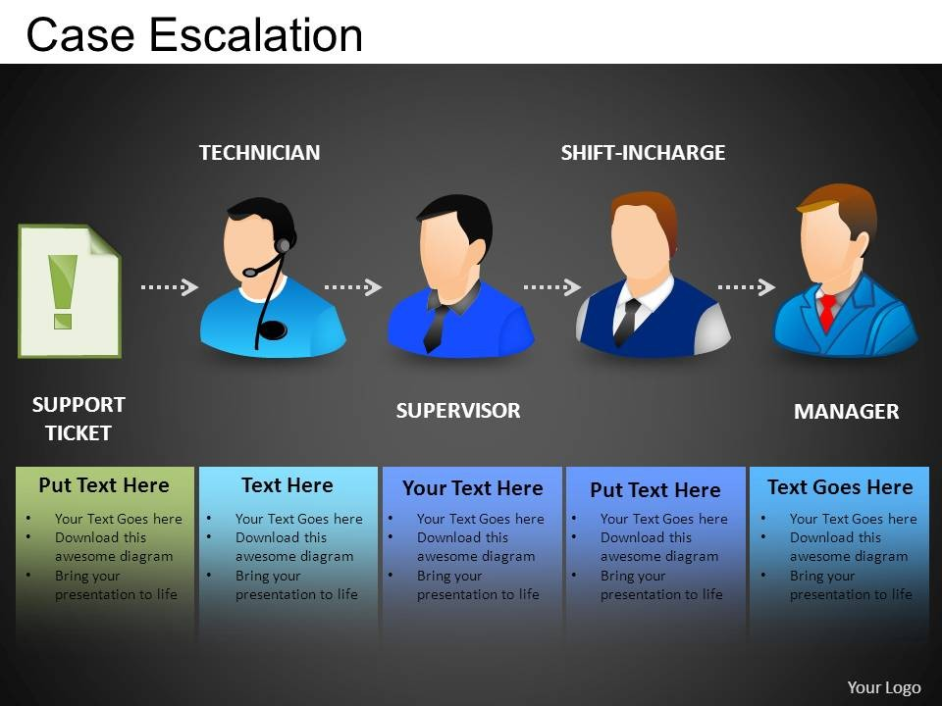

Below is an example checklist of questions that should be asked to determine.

Checklist before escalating an issue to next level

* Is this an infrastructure / product issue?
* Is it a bug or this is a request for feature enhancement?
* Was a workaround provided and acceptable?
* What is the business impact of the issue?

Does the request require a change in the workflow or process?

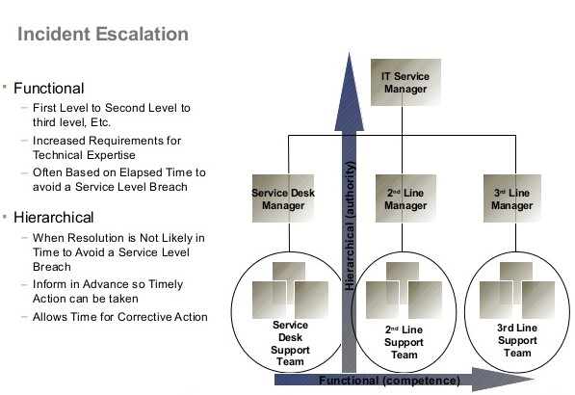

## Service Maintenance & Downtime

Napier cloud has the following downtimes for the maintenance of the environment

* Schedule maintenance
* Emergency maintenance

The target service availability is 99.99999% excluding the downtimes.

The Actual availability is 99.5% including scheduled downtimes

* This does not include emergency downtimes.

Calculation for the above service availability is = 1.25% per scheduled downtime per quarter

* No. of downtimes in a year = 4
* Service availability in a calendar year = 99.5(100-(1.25 *4)) %
* **Emergency Maintenance**means downtime of the Hosted Service outside of Scheduled Maintenance that is required to apply urgent patches or fixes, or undertake other urgent maintenance activities.
  + Through the high availability zone, DR, clustering all efforts would be made to achieve the 99.999% availability and minimize the impact, there could always be exceptions beyond the control of Napier
  + Napier will work with the customer IT and cloud vendor to recover the system with minimal impact to the business. The team would perform root cause analysis and along with its engineering team would provide the resolution or an estimated time within which the system would be available
* **Scheduled Maintenance** is scheduled in advance and Napier will provide Customer with minimum four (4) business days’ advance notification. Scheduled Maintenance will not exceed four (4) hours in any consecutive three-month period.
  + In certain cases, where a known maintenance release is to be deployed depending on the size, this maintenance window could be more than 4 hrs., and same would be notified to the customer

Downtime Schedule – last Friday of every quarter

* Q1 2017 – 24th March 2017
* Q2 2017 – 30th June 2017
* Q3 2017 – 29th September 2017
* Q4 2017 – 29th December 2017

Duration – Approx. 2-3 Hours

Time - midnight local time

Activities to be performed

1. Windows security patches
2. Application patches if any
3. Application server backup and archiving
4. Anti-Virus – software and definition updates